## 图片：1.png

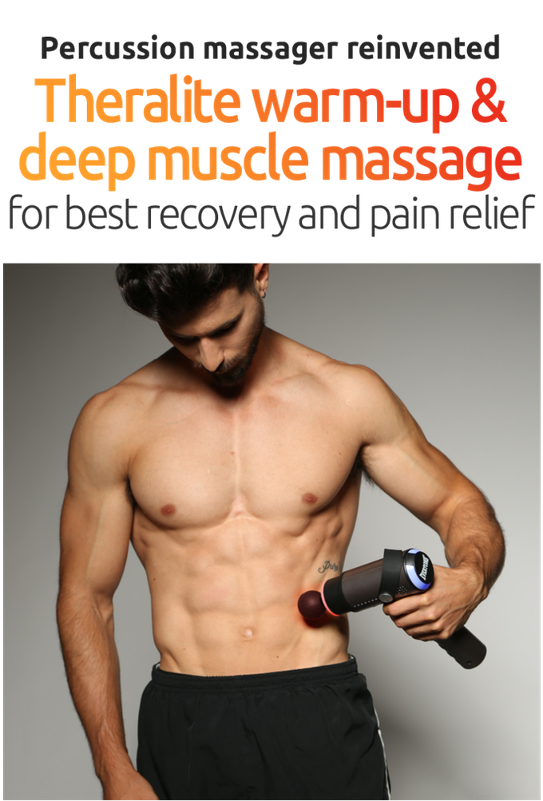

## 识别原文：

Percussion massager reinvented  
Theralite warm-up  
deep musde massage  
for best recovery and pain relief

## 图片：10.png

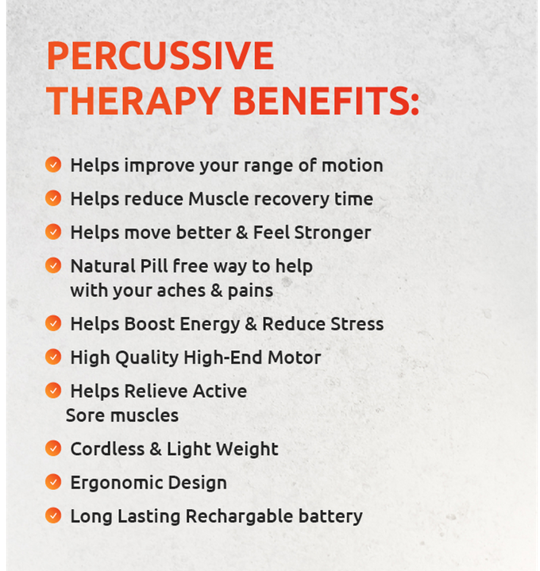

## 识别原文：

PERCUSSIVE  
THERAPY BENEFITS.  
o Helps improve your range of motion  
o Helps reduce Muscle recovery time  
o Helps move better Feel Stronger  
o Natural Pill free way to help  
with your aches pains  
Helps Boost Energy Reduce Stress  
O High Quality High-End Motor  
o Helps Relieve Active  
Sore muscles  
0 Cordless Light Weight  
Ergonomic Design  
Long Lasting Rechargable battery

## 图片：11.png

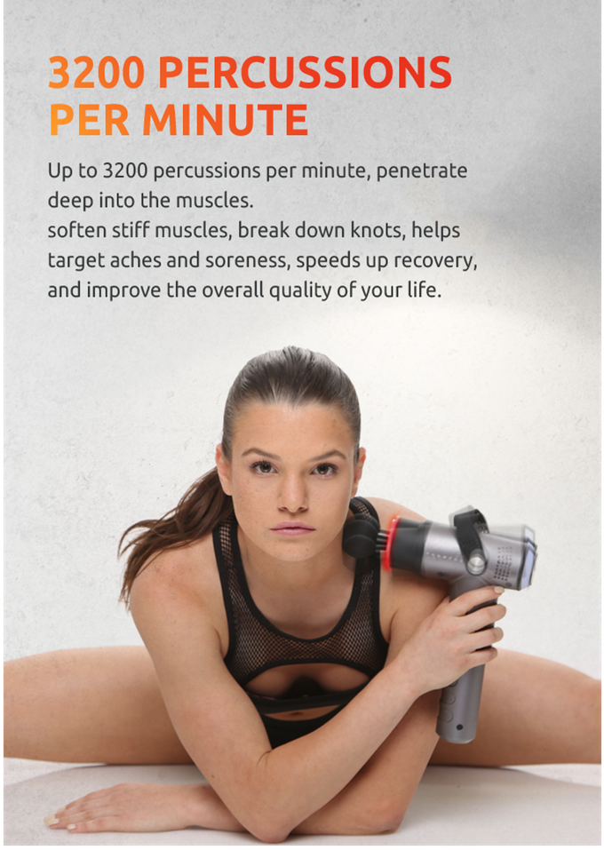

## 识别原文：

3200 PERCUSSIONS  
PER MINUTE  
Up to 3200 percussions per minute, penetrate  
deep into the muscles  
soften stiff muscles, break down knots, helps  
target aches and soreness, speeds up recovery  
and improve the overall quality of your life

## 图片：12.png

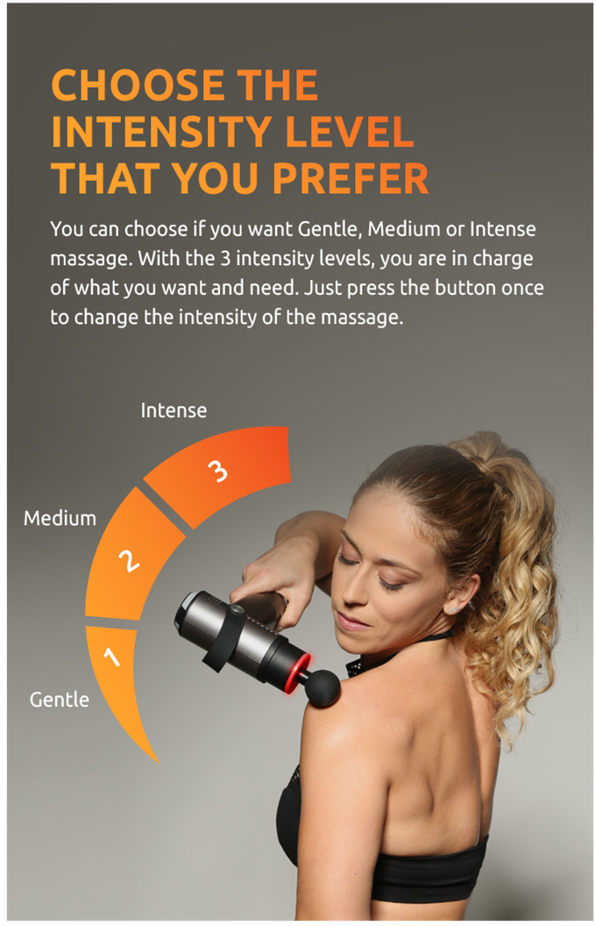

## 识别原文：

CHOOSE THE  
NTENSITY LEVEL  
THAT YOU PREFER  
You can choose if you want Gentle, Medium or Intense  
massage With the 3 intensity levels, you are in charge  
of what you want and need. Just press the button once  
to change the intensity of the massage.  
Intense  
Medium  
Gentle

## 图片：13.png

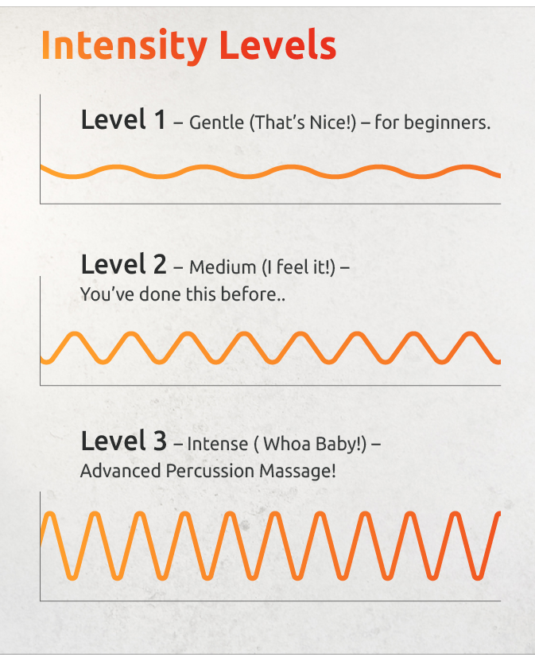

## 识别原文：

Intensity Levels  
evel 1-Gentle(That's Nice!)-for beginners  
Level 2-Medium( feel it!  
Youve done this before  
Level 3-Intense( Whoa Baby!)  
Advanced Percussion Massage

## 图片：14.png



## 识别原文：

SUNIQUE  
MASSAGE HEADS

## 图片：15.png

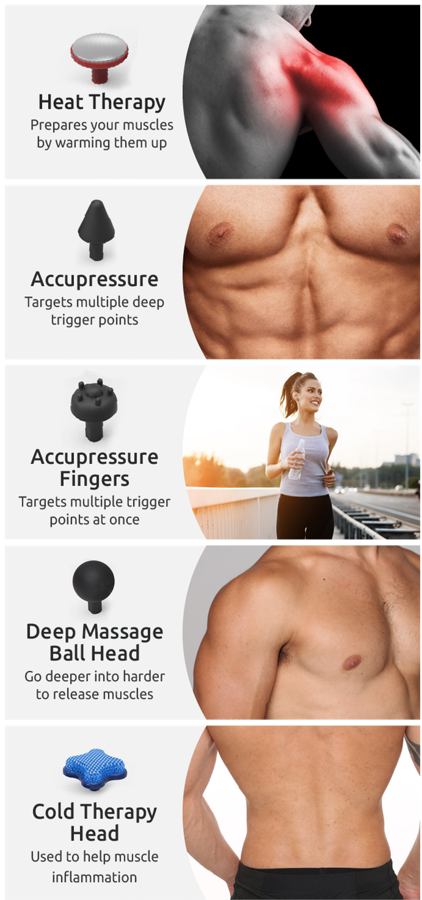

## 识别原文：

Heat Therapy  
Prepares your muscles  
by warming them up  
Accupressure  
Targets multiple deep  
trigger points  
Accupressure  
Fingers  
Targets multiple trigger  
points at once  
Deep Massage  
Ball Head  
Go deeper into harder  
to release muscles  
Cold Therapy  
Head  
Used to help muscle  
Flammation

## 图片：16.png

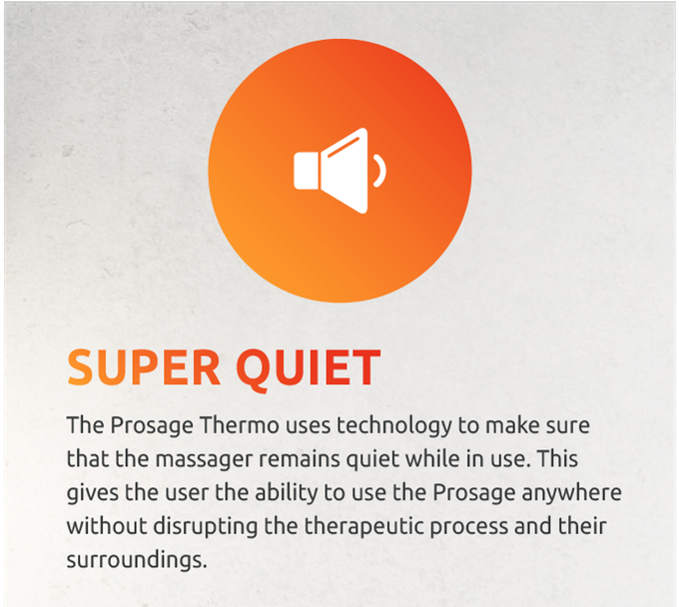

## 识别原文：

SUPER QUIET  
The presage Thermo uses technology to make sure  
that the massager remains quiet while in use. This  
gives the user the ability to use the Prosage anywhere  
without disrupting the therapeutic process and their  
surroundings.

## 图片：17.jpg

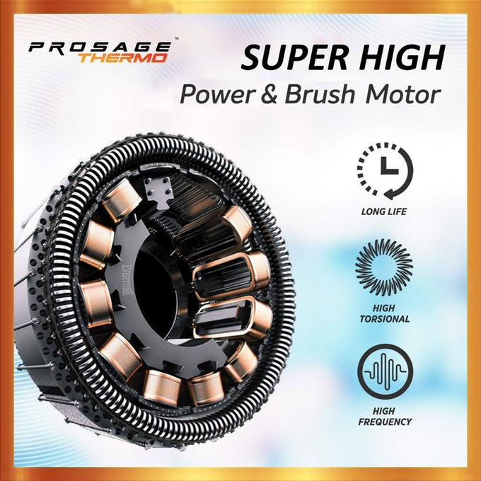

## 识别原文：

尸RAG  
SUPER HIGH  
Power& brush motor  
LONG LIFE  
小N  
HIGH  
TORSIONAL  
FREQUENCY

## 图片：18.png

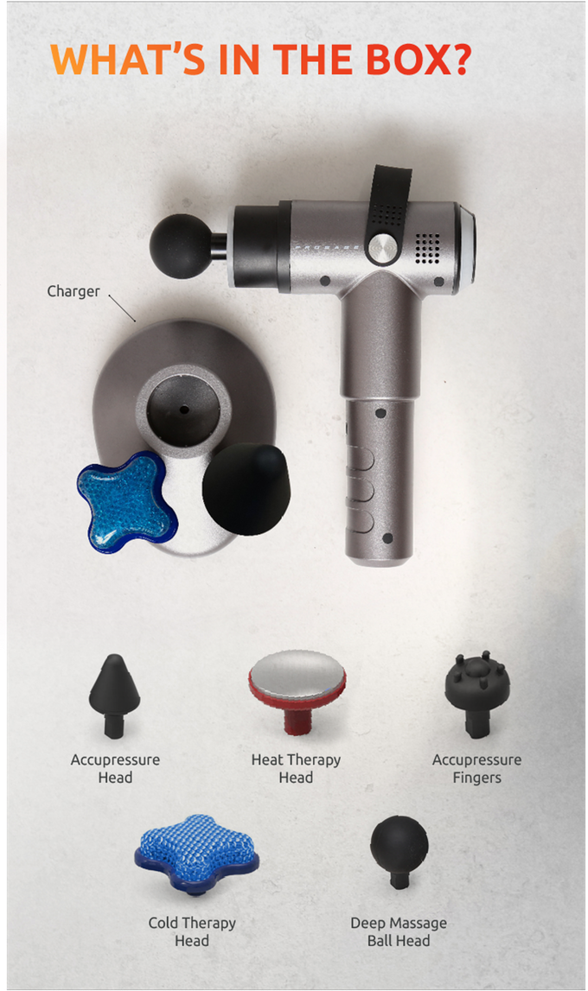

## 识别原文：

WHAT S IN THE BOX?  
Char  
Accupressure  
Heat Therapy  
Accupressure  
Head  
Fingers  
Cold Therapy  
Deep massage  
Ball Hea

## 图片：19.png

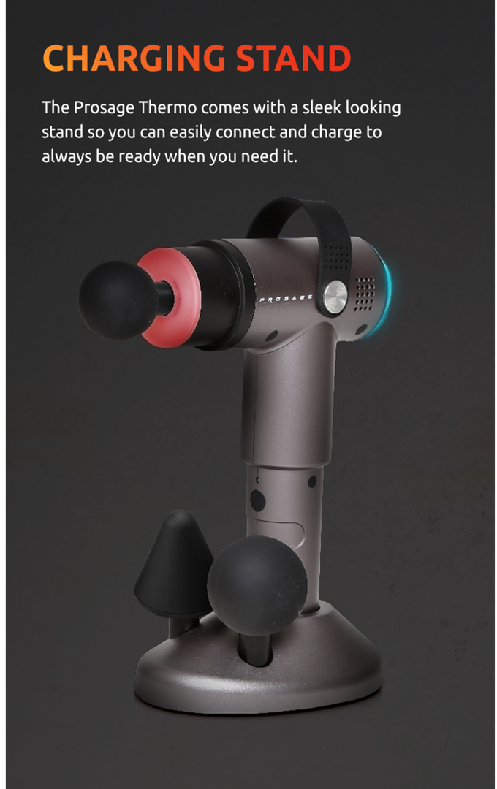

## 识别原文：

CHARGING STAND  
The presage thermo comes with a sleek looking  
stand so you can easily connect and charge to  
always be ready when you need it

## 图片：2.png

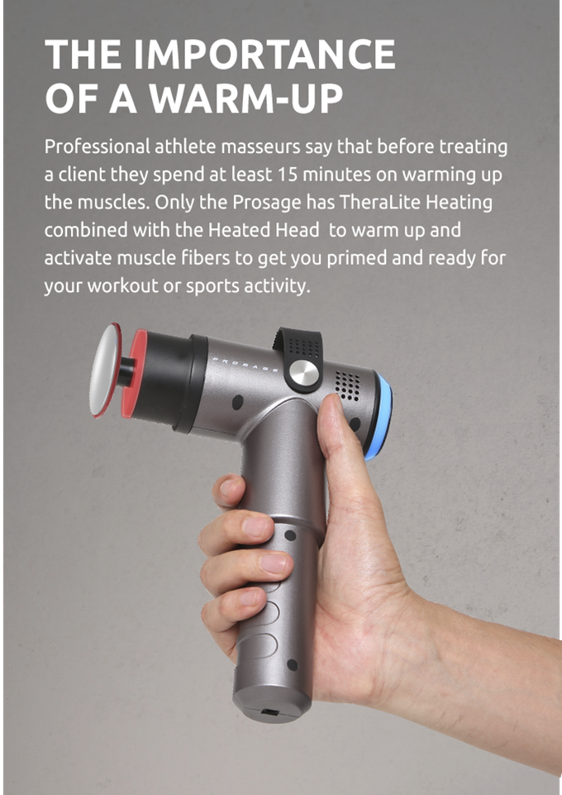

## 识别原文：

THE IMPORTANCE  
OF A WARM-UP  
Professional athlete masseurs say that before treating  
a client they spend at least 15 minutes on warming up  
the muscles. Only the Prosage has TheraLite Heating  
combined with the Heated Head to warm up and  
activate muscle fibers to get you primed and ready for  
your workout or sports activity.

## 图片：20.png

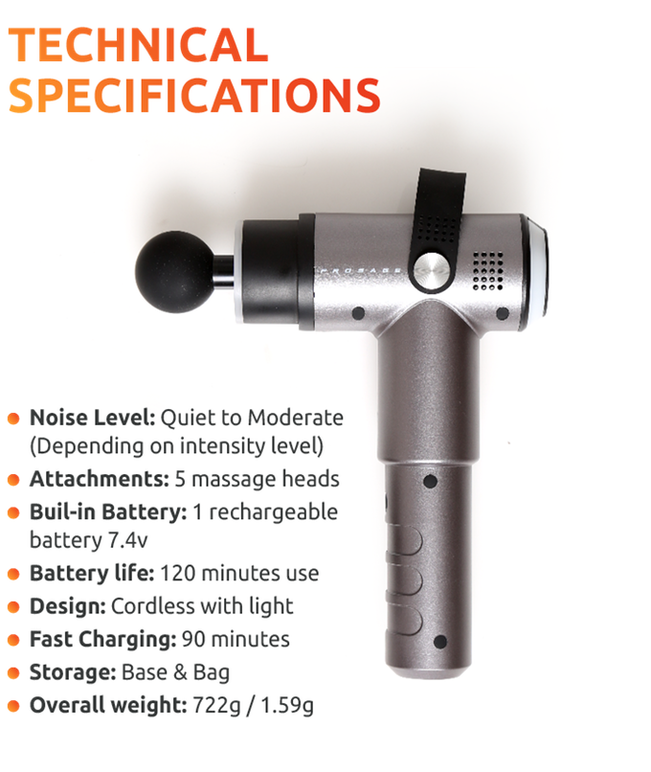

## 识别原文：

TECHNICAL  
PECIFICATIONS  
e。  
o Noise Level: Quiet to Moderate  
Depending on intensity level)  
aTtachments: 5 massage heads  
o Buil-in Battery: 1 rechargeable  
battery 7. 4v  
o Battery life: 120 minutes use  
o pesign: Cordless with light  
o Fast Charging: 90 minutes  
● torage:Base&Bag  
e overall weight: 7229/1.59g

## 图片：3.png

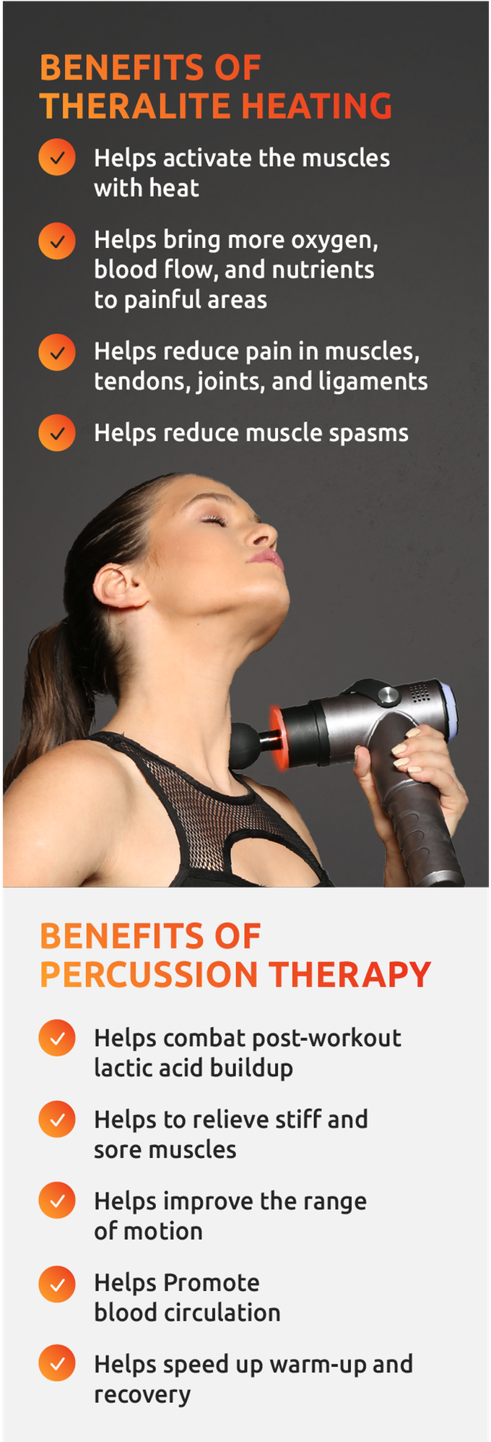

## 识别原文：

BENEFITS OF  
THERALITE HEATING  
Helps activate the muscles  
with heat  
Helps bring more oxygen  
blood flow, and nutrients  
to painful areas  
Helps reduce pain in muscles,  
tendons joints, and ligaments  
Helps reduce muscle spasms  
BENEFITS OF  
PERCUSSION THERAPY  
Helps combat post-workout  
lactic acid buildup  
Helps to relieve stiff and  
sore muscles  
Helps improve the range  
of motion  
Helps promote  
blood circulation  
Helps speed up warm-up and  
recovery

## 图片：4.png

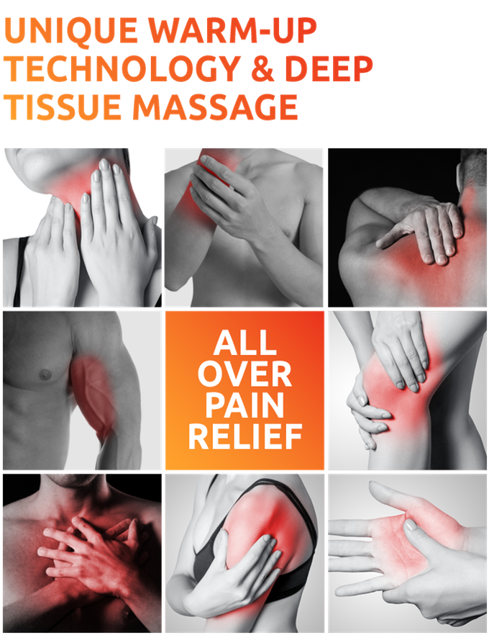

## 识别原文：

UNIQUE WARM-UP  
TECHNOLOGY & DEEP  
TISSUE MASSAGE  
ALL  
OVER  
RELIEF F

## 图片：5.jpg

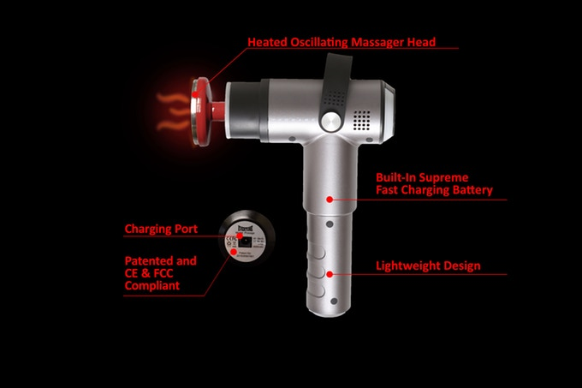

## 识别原文：

Heated Oscillating Massager Head  
○  
Built-In Supreme

## 图片：6.png

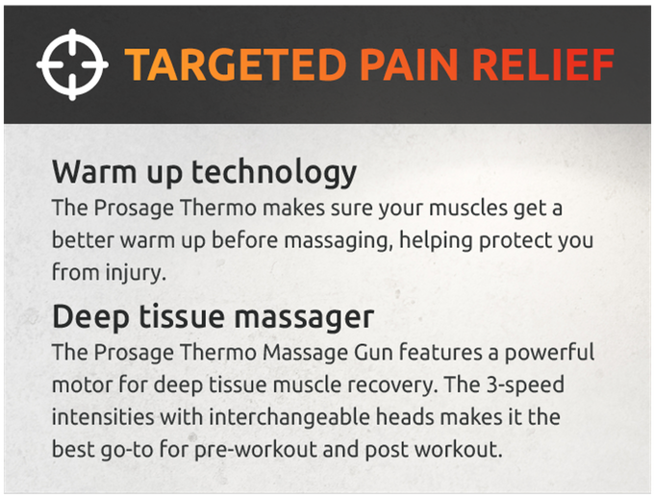

## 识别原文：

TARGETED PAIN RELIEF  
Warm up technology  
The presage Thermo makes sure your muscles get a  
better warm up before massaging, helping protect you  
from injury.  
Deep tissue massager  
The Prosage Thermo Massage Gun features a powerful  
motor for deep tissue muscle recovery. The 3-speed  
intensities with interchangeable heads makes it the  
best go-to for pre-workout and post workout

## 图片：7.png

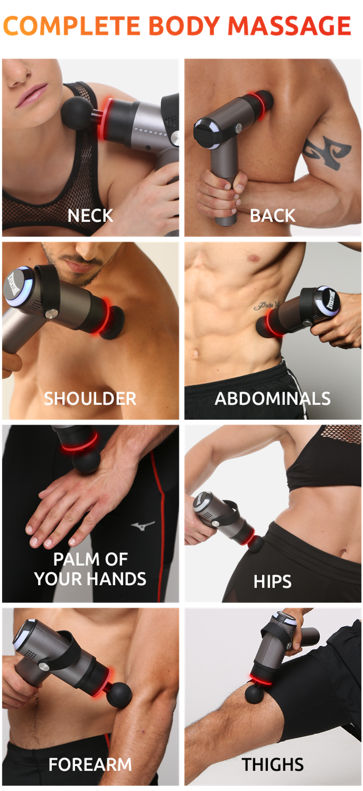

## 识别原文：

COMPLETE BODY MASSAGE  
NECK  
BACK  
SHOULDER  
ABDOMINALS  
PALM OF  
YOUR HANDS  
HIPS  
FOREARM  
THIGHS

## 图片：8.png

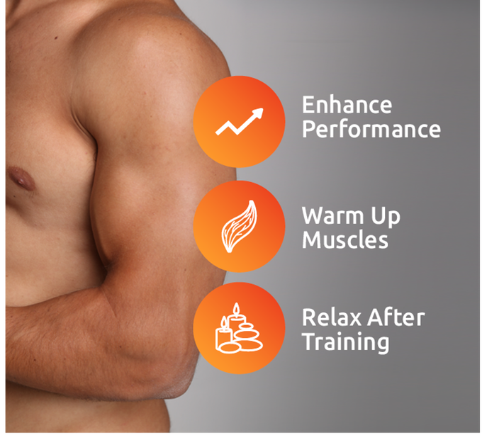

## 识别原文：

Enhance  
Performance  
Warm UP  
Muscles  
Relax After  
Training

## 图片：9.png



## 识别原文：

PROSAGE NOT ONLY FOR  
PROFESSIONAL ATHLETES